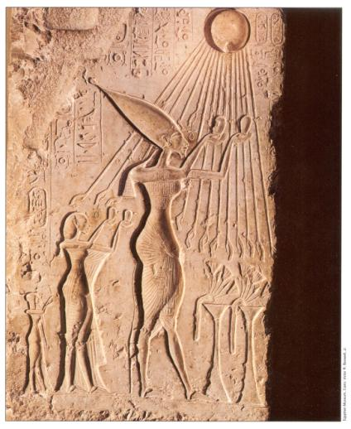Akenaton & Nefertiti ca. 1380 BCE

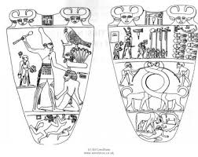 Narmer Pallette 3100 BCE
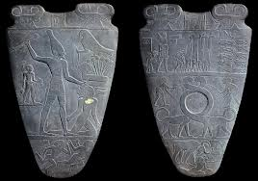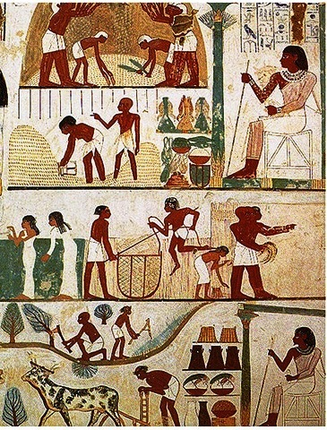 Tomb Painting 13th cent. BCE

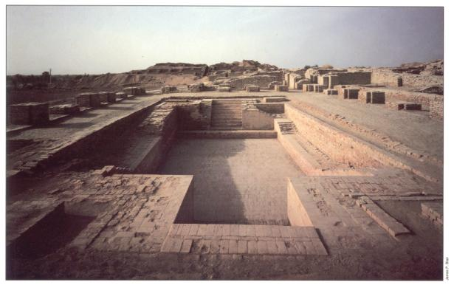 Great Bath at Mohenjo-Daro. 2500 BCE. Public bath and public plumbing exhisted throughout the city .

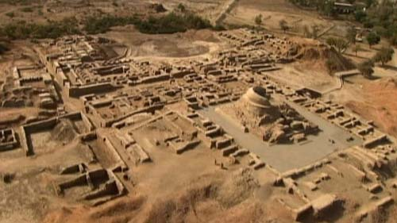
Harrapan City Plan 2000 BCE

We have found very few examples of writing in Harapan civilization, except stamps likes these below. What are some possible reasons we have found little evidence of writing?
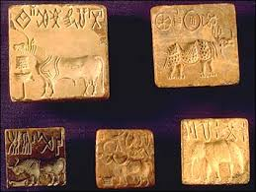
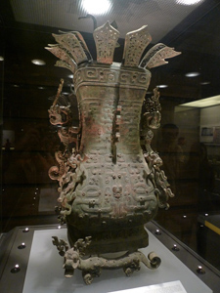
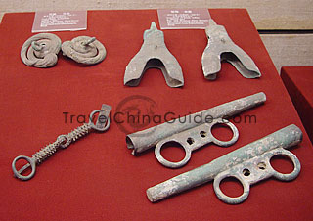
Charriot Parts 700’s BCE

Bronze Wine Vessel 1200s BCE Zhough
Dynasty

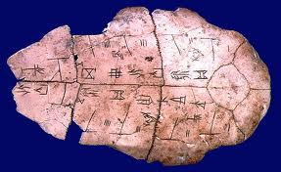 Writing on Tortose Shell 1500 BCE
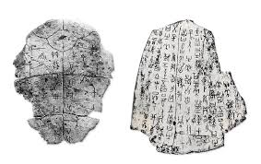

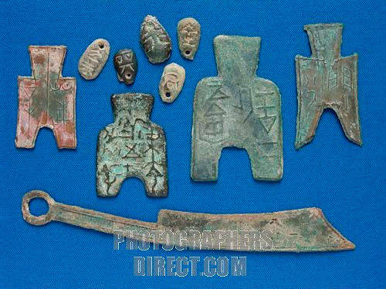Zhou Currency with writing on it ca. 500 BCE
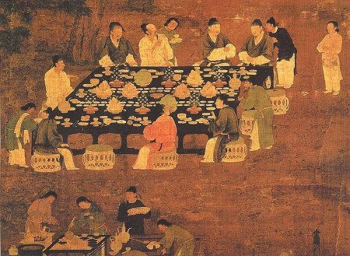
Wall Art from Ancient China ca 500 BCE

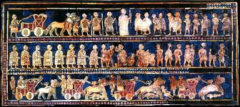

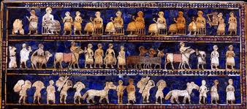
Standard at Ur 2400 BCE Mesopotamia made of wood. You are view both sides of the same wooden box

Hymn to the Nile 2100 BCE
Hail to thee, O Nile! Who manifests thyself over this land, and comes to give life to Egypt! Mysterious is thy issuing forth from the darkness, on this day whereon it is celebrated! Watering the orchards created by Re, to cause all the cattle to live, you give the earth to drink, inexhaustible one! Path that descends from the sky, loving the bread of Seb and the first-fruits of Nepera, You cause the workshops of Ptah to prosper!
Lord of the fish, during the inundation, no bird alights on the crops. You create the grain, you bring forth the barley, assuring perpetuity to the temples. If you cease your toil and your work, then all that exists is in anguish. If the gods suffer in heaven, then the faces of men waste away.

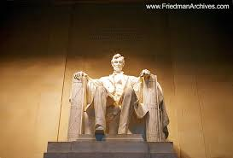
Lincoln Memorial

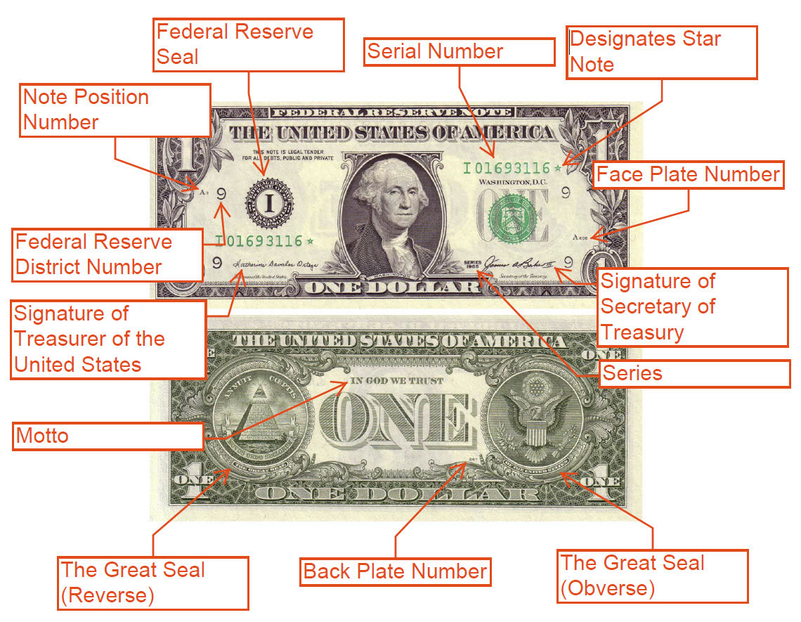

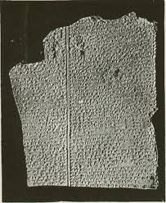
That city was ancient, (as were) the gods within it,
When their heart led the great gods to produce the flood.
There were Anu, their father,
Valiant Enlil, their counsellor,
Ninurta, their herald,
Ennuge, their irrigator.
Ninigiku-Ea was also present with them;
Their words he repeats to the reed-hut (home of Utnapishtim):
‘Reed-hut, reed-hut! Wall! Wall!
Reed-hut, hearken! Wall, reflect!
Man of Shuruppak (Utnapishtim), son of Ubar-Tutu,
Tear down (this) house, build a ship!
Give up possessions, seek thou life.
Despise property and keep the soul alive.

Six days and six nights
Blows the flood wind, as the south-storm sweeps the land.
When the seventh day arrived,
The flood (-carrying) south-storm subsided in the battle,
Which it had fought like an army.
The sea grew quiet, the tempest was still, the flood ceased.
I looked at the weather: stillness had set in,
And all of mankind has returned to clay.
The landscape was as level as a flat roof.
I opened a hatch, and light fell on my face.
Bowing low, I sat and wept,
Tears running down my face.
I looked about the coast lines in the expanse of the sea:
In each of fourteen (regions)

