Name_____________________________________

Words in Context
Ancient Greece was made up of small City-States, known as a Polis. In this Polis, citizens were expected to participate in a Political process to govern the Polis. At first it was just the Aristocracy that ruled, but over time Athens developed into a more equal Democracy. This was due to the movement known as Philosophy, which used reason to search for explanations of how to live life. Because Philosophers used reason to understand life, and not the gods, they created the first form of Secular living. All of this still impacts us today, right down to our Police force who protect citizens living in a modern Polis.

On the blank map below locate the major Greek city-states listed. Locate the Persian Empire, and draw the route they would have taken to get to Thermopylae. Use p 7 in the atlas & p 105, 106, 111 in the text for reference.
Aegean Sea  Crete  Athens  Sparta | Thermopylae  Ionia  Persian Empire  Hellespont | Corinth  Thebes  Macedonia  Ancient Troy

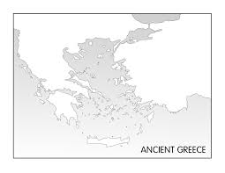

Looking at the Map on pages in your book:

What Physical features of Greece’s Geography make it different from the other major civilizations & empires we have examined so far in the course?

How are these an advantage and a disadvantage?

Based on the map, why is Ancient Greece so many small city-states? Why not one centrally controlled empire?

How do you think this affects the Greek attitude towards government?

