Name___________________________________ Period_____
Lost in Translation: An example of the difficulty in studying ancient texts

NJ Dawood 2003 | Alexander Ross 1649
1. This day I have perfected your religion for you, completed My favour to you. I have chosen Islam to be your faith.  2.The only true faith in God’s sight is Islam  3. It is He who has sent forth His apostle with guidance and the True Faith that he may exalt it above all religion, though idolater abhor it. | 1. The day will come, when I shall accomplish your law, and my Grace shall be abundantly upon you: The Law of Salvation, is the Law that I desire to give you  2.The Law of Salvation is a law pleasing to his Diving Majesty.  3. He hath sent his Prophet to conduct men into the right way to preach the Law of Truth, and to make it eminent above all other Laws of the world, against the will of Idolaters

What difference do you notice in the translations above?

How do those differences change the meaning of the text?

Which one is correct?

How can we use contextualizing to help us figure out which translation is more accurate?

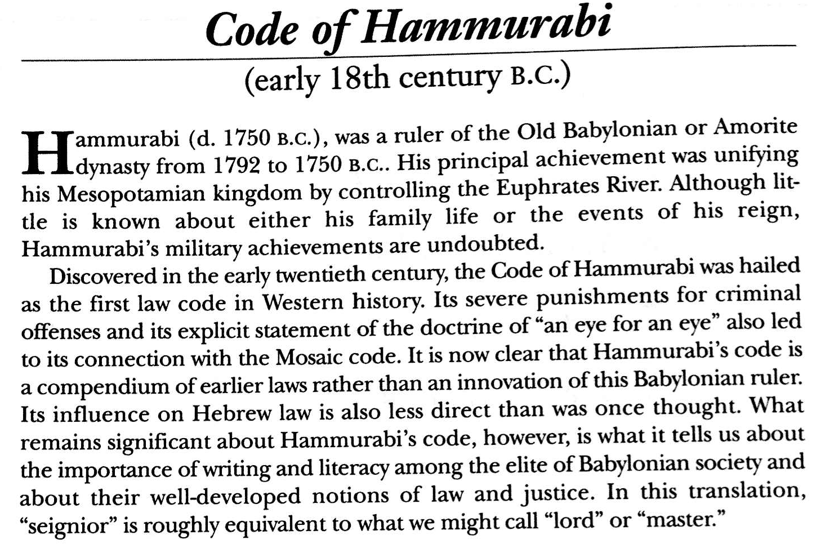
Using the handout and the background above, source and contextualize the document

Intro to the Code:
Then Anu and Bel called by name me, Hammurabi, the exalted prince, who feared God, to bring about the rule of righteousness in the land, to destroy the wicked and the evil-doers; so that the strong should not harm the weak; so that I should rule over the people and enlighten the land, to further the well-being of mankind. Hammurabi, the prince, called of Bel am I, making riches increase…who conquered the four corners of the world and made great the name of Babylon…When Marduk sent me to rule over men, to give the protection of right to the land, I did right and righteousness…

Does this section give us any clues that can help us source or contextualize our document?
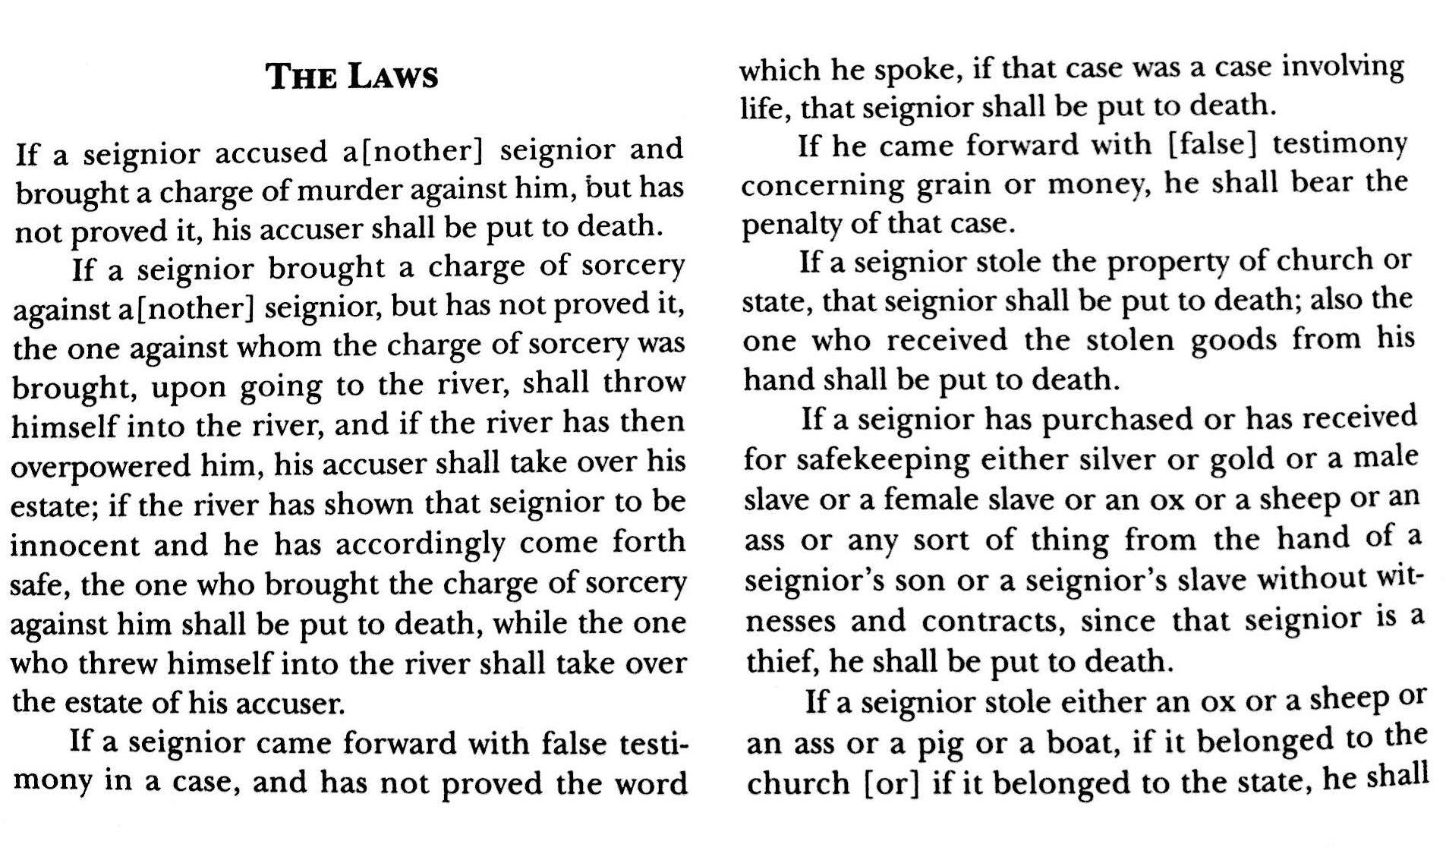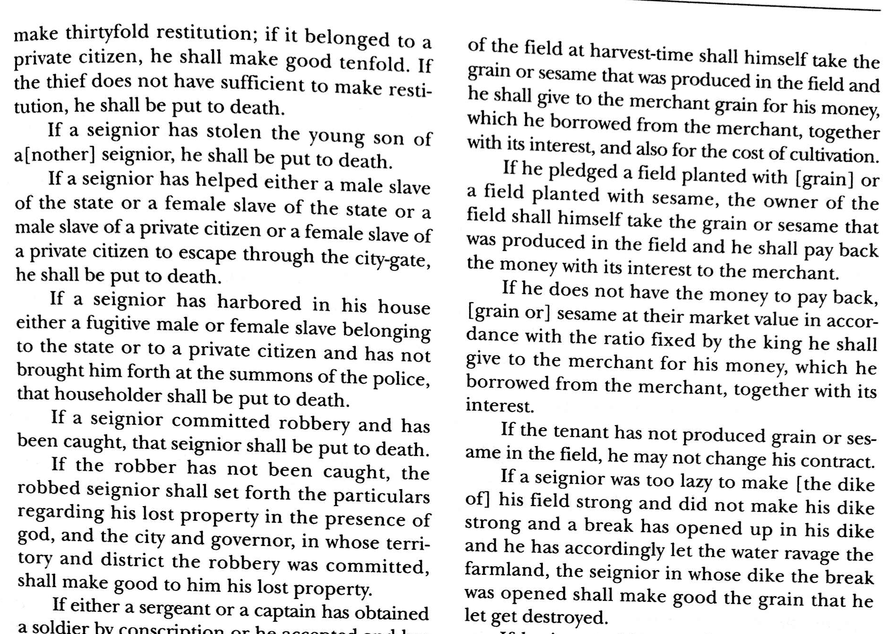

Can we learn anything for the laws that help us contextualize this?
- How was life different then?
- How was life similar?
- Would we approve of these laws today?

