Go to www.mrgarnershistory.weebly.com and find the link to the Museum site under “Classwork” and in the unit “Ancient Israel”.

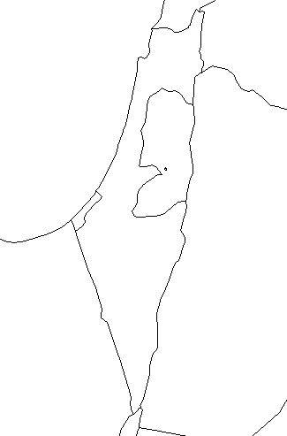
On the map of Israel, label the location of Jerusalem and Lachish. Then draw an arrow to show which direction the Assyrians would be invading from.

Listen to or read the podcast to get background information on the Lachish Reliefs

- What is the purpose of the stone carvings?

- Why are they such a significant archeological find for historians?

- What is Lachish?

- Hezekiah is the King of Jerusalem and is advised by the Prophet Isaiah. What does Isaiah advise Hezekiah to do that causes the Assyrians to attach Lachish?

- What is unique about our sources for understanding of this ancient war, compared to most other ancient wars?

You are now going to go through the reliefs on at a time and look for particular features. When you click on each relief, it will come up on screen. If you zoom in you will see teal dots appear on the relief that will point to important details on the relief. This will help you analyze the reliefs as you go. The reliefs describe the battle in order, so you can see a narrative like a graphic novel.

There is 1 question for each relief (7 total)
- In the first relief, what is most likely taking place based on what you observe? Support your answer with reference to specific parts of the picture.

- Who is depicted beginning the siege in scene 2? (2 types of soldiers)?

- What is the name of the infantry that is first attaching the walls of Lachish in scene 3?

- Scene 4 shows violent parts of the battle at the top of the relief, and the consequences of the battle for the Judeans at the bottom. Describe how the battle was fought, and what happened to the losers based on this relief.
  - How it was fought:

  - Consequences:

- What specific objects are carried as booty to the King in scene 5?

- Scene 6 shows a gruesome torture method at the bottom, what is happening?

- Scene 7 shows the end of the victory parade. Who is being honored for the victory?

