Name _________________________
Plessy v Ferguson

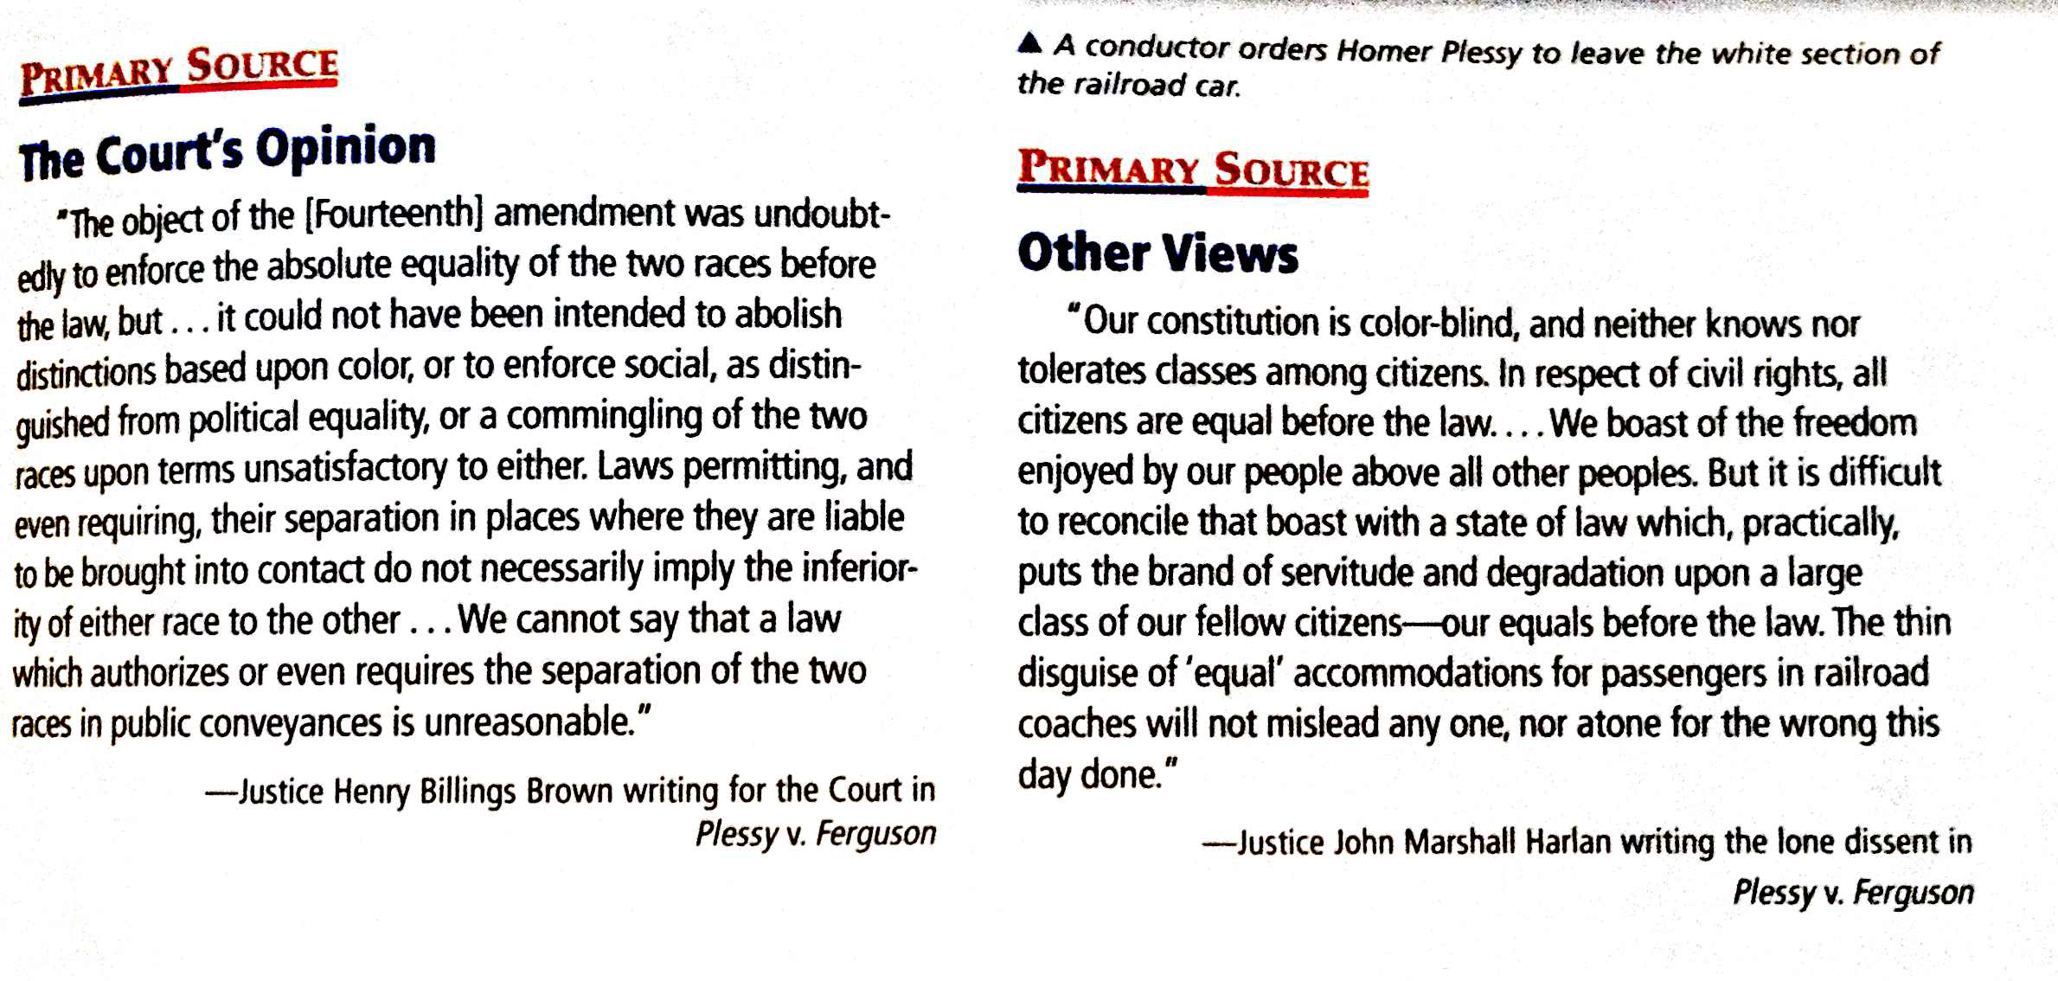

What are the impacts of the courts decision on the laws in states and the everyday life of African Americans?

What is a Majority Decision?

What is a dissenting opinion?

How does the court decide cases?

Circle any words you think are important or that are you unsure of the meaning. List words and definitions as we go over them in class.

Underline 1-2 key sentences that you believe are important in each document

What is the main difference between the point of view of Justice Brown and Justice Harlan?

